**List out the entities and identify the relationship between them. Also, identify related attributes supposed to be recorded while considering the normalization rule.**

Table of Contents

*Introduction* 2

1.) Entities 3

1.1) User 3

1.2) Expense 3

1.3) Notifications 3

1.4) Categories 3

1.5) Budget 3

1.6) Transactions 3

1.7) Admins 4

2.) Relationships 5

2.1) User - Expense (One-to-Many) 5

2.2) Notifications - User (One-to-Many) 5

2.3) Categories - User (One-to-Many) 5

2.4) Budget - User (One-to-Many) 5

2.5) Transactions – User (One-to-Many) 5

2.6) Admin: Relationship: 5

3.) Entity Relationship Diagrams 6

3.1) User-Expense Entity Relationship Diagram 6

3.2) Categories- User Entity Relationship Diagram 6

4.) Normal Forms 7

4.1) First Normal Form (1NF) 7

4.2) Second Normal Form (2NF) 8

5.) Schema 8

*6.)* Database Normalization 8

# *Introduction*

*To identify entities and relationships in a database schema, as well as the related attributes while considering normalization rules, we'll use the context of your project, the "Web-Based Voice-Activated Expense Tracking and Geo-Limit Enforcement App."*

*Here are some key entities, their relationships, and attributes:*

# Entities

## 1.1) User

* Attributes: UserID (Primary Key), Username, Password (Hashed), Email, Registration Date, Last Login Date, budget amount

## 1.2) Expense

* Attributes: ExpenseID (Primary Key), UserID (Foreign Key), Amount, Description, Date, Location (Latitude, Longitude)

## 1.3) Notifications

* Attributes: NotificationID (Primary Key), UserID (Foreign Key), Message, Timestamp, Status (Read/Unread)

## 1.4) Categories

* Attributes: CategoryID (Primary Key), UserID (Foreign Key), Name, Description

## 1.5) Budget

* Attributes: BudgetID (Primary Key), UserID (Foreign Key), Name, Amount, Start Date, End Date

## 1.6) Transactions

* Attributes: TransactionID (Primary Key), UserID (Foreign Key), Amount, Description, Date

# 1.7) Admins

* *Attributes: AdminID (Primary Key), Username, Password (Hashed), Email, Role (Admin/Manager)*

# Relationships

## 2.1) User - Expense (One-to-Many)

* Each user can have multiple expenses.
* Each expense belongs to one user.
* Relationship Attribute: UserID (Foreign Key in the Expense table)
* **Normalization rules, specifically the First Normal Form (1NF) and Second Normal Form (2NF), should guide the design and attributes of these entities:**

## 2.2) Notifications - User (One-to-Many)

* Each user can receive multiple notifications.

## 2.3) Categories - User (One-to-Many)

* *Each user can have multiple categories for expenses*

## 2.4) Budget - User (One-to-Many)

* Each user can have multiple budgets

## 2.5) Transactions – User (One-to-Many)

* Each user can have multiple transactions

2.6) Admin: Relationship: N/A (This entity might not be directly linked to users but could be used for system administration).

# Entity Relationship Diagrams

## 3.1) User-Expense Entity Relationship Diagram

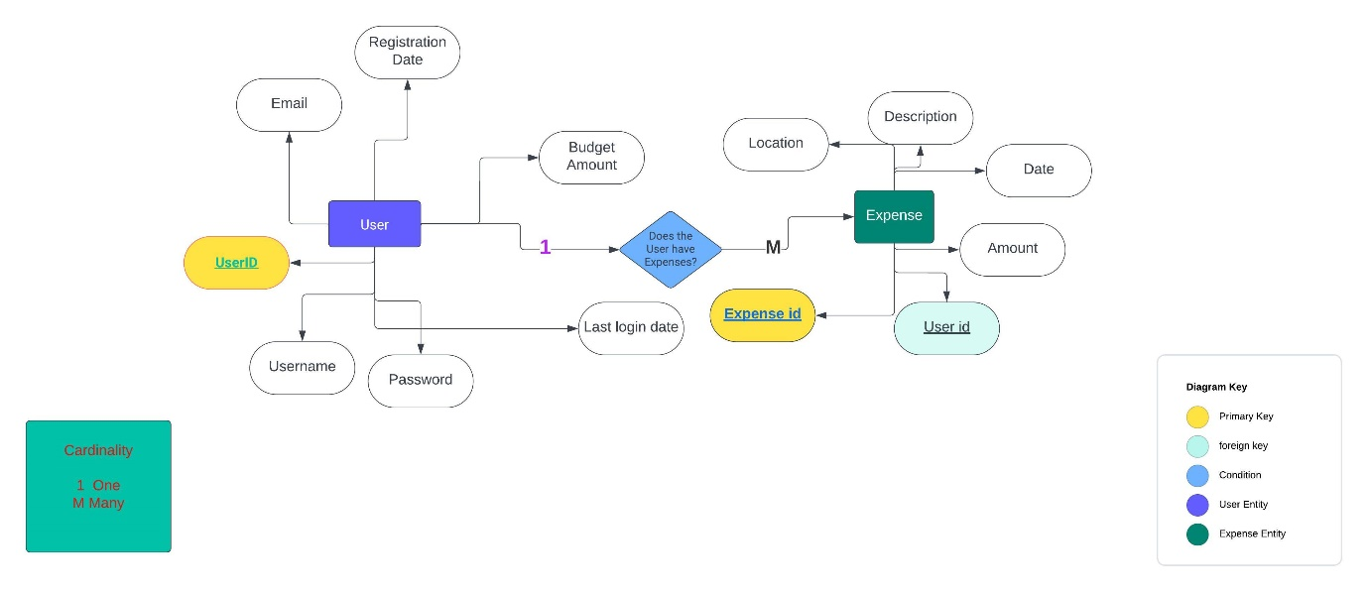

**Figure 1 User-Expense Entity Relationship Diagram**

## 3.2) Categories- User Entity Relationship Diagram

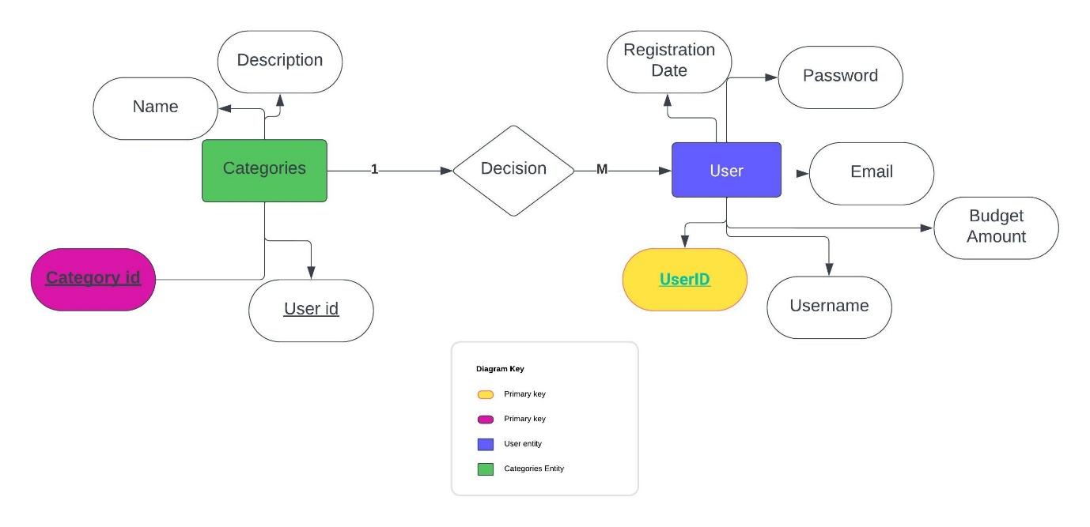

Figure 2 Categories- User Entity Relationship Diagram

# Normal Forms

## 4.1) First Normal Form (1NF)

* + - All attributes are atomic (indivisible).
    - Attributes contain no repeating groups or arrays.
    - Each attribute has a unique name.
    - Attributes are of the same data type.

## 4.2) Second Normal Form (2NF)

* + It satisfies 1NF.
  + It has a primary key.
  + All non-key attributes are fully functionally dependent on the primary key.

## Schema

1. The User entity is in 1NF, with atomic attributes like Username and Password.
2. The Expense entity is in 1NF, with atomic attributes like Amount and Description.
3. The Geographical Area entity is in 1NF, with atomic attributes like Name and Spending Limit.

## Database Normalization

*Normalization often depends on real-world requirements and constraints, so further normalization may be needed based on specific use cases and data integrity requirements. However, the initial design ensures that attributes are atomic and have clear dependencies on primary keys, which is a good starting point for database schema design.*